Synopsis of Vehicle Vault Intelligent Car Comparison & Marketplace
ABSTRACT
The rapid growth of the automobile industry has led to an overwhelming number of vehicle choices for consumers, making the decision-making process complex and time-consuming. To address this challenge, the E-CAR (Car Comparison & Marketplace System) is developed as a comprehensive web-based platform that enables users to compare cars efficiently and engage in buying and selling activities within a single system.
The proposed system is built using the MERN stack, which includes MongoDB, Express.js, React, and Node.js, ensuring a scalable and high-performance application. The platform allows users to register and log in securely using JWT-based authentication. Users can explore a wide range of cars, view detailed specifications such as price, engine performance, mileage, and features, and compare multiple vehicles side by side to make informed decisions.
In addition to comparison functionality, the system includes a marketplace module where users can list their own vehicles for sale and browse listings posted by others. A role-based access control mechanism is implemented to differentiate between regular users and administrators. The admin has full control over managing car data, including adding, updating, and deleting vehicle records.
The system also incorporates a simulated payment module to demonstrate transaction flow without involving real financial processing, ensuring safety and simplicity for academic purposes. Furthermore, image upload functionality is implemented using local storage to manage car and listing images effectively.
The E-CAR system aims to simplify the car selection process, enhance user experience through an intuitive interface, and provide a unified platform for comparison and marketplace activities. This project demonstrates the practical implementation of modern web technologies in solving real-world problems and highlights the importance of user-centric design in application development.

INTRODUCTION
In today’s fast-paced world, the automobile industry is experiencing rapid growth with a wide variety of vehicles being introduced frequently. Consumers are presented with numerous options in terms of brands, models, features, and pricing. While this abundance of choices is beneficial, it also creates confusion and difficulty in selecting the most suitable vehicle. Buyers often need to visit multiple websites or showrooms to compare different cars, which is time-consuming and inefficient.
With the advancement of web technologies, there is a growing need for a centralized platform that can simplify the process of comparing cars and facilitate buying and selling activities. Traditional methods of car selection lack a unified system where users can evaluate multiple vehicles side by side based on important specifications such as price, engine performance, mileage, and additional features.
To address these challenges, the E-CAR (Car Comparison & Marketplace System) is developed as a web-based application that integrates both comparison and marketplace functionalities into a single platform. The system is designed to provide users with an easy and efficient way to explore various car options, analyze their differences, and make informed decisions.
The application is built using the MERN stack, which includes MongoDB for database management, Express.js and Node.js for backend development, and React for frontend user interface design. This modern technology stack ensures scalability, performance, and a seamless user experience. The system follows a structured architecture where the frontend communicates with backend APIs, and data is stored and retrieved from a centralized database.
One of the key features of the system is the car comparison module, which allows users to select two cars and view their specifications side by side. This helps users identify the strengths and weaknesses of each vehicle easily. In addition, the platform includes a marketplace feature where users can list their own cars for sale and browse listings posted by other users. This creates an interactive environment that benefits both buyers and sellers.
The system also implements role-based access control, distinguishing between regular users and administrators. While users can explore, compare, and list cars, the administrator has the authority to manage the car database, ensuring that accurate and up-to-date information is available on the platform.
Furthermore, the application incorporates secure authentication using JSON Web Tokens (JWT), ensuring that user data is protected. A simulated payment module is also included to demonstrate transaction flow within the system without involving real financial operations, making it suitable for academic purposes.
Overall, the E-CAR system aims to enhance user experience by providing a centralized, efficient, and user-friendly platform for car comparison and marketplace activities. It reduces the complexity involved in decision-making and leverages modern web technologies to deliver a practical solution to real-world problems.

SCOPE OF THE PROJECT
The scope of the E-CAR (Car Comparison & Marketplace System) is to provide a centralized and efficient platform for users to compare different cars and engage in buying and selling activities. The system is designed to simplify the decision-making process for users by offering detailed information and comparison features within a single application.
The primary scope of the project includes enabling users to register and securely log in to the system using authentication mechanisms. Once authenticated, users can explore a wide range of cars, view detailed specifications such as price, engine performance, mileage, and additional features, and compare two vehicles side by side to identify the most suitable option based on their preferences.
Another important aspect of the system is the marketplace functionality. Users can list their own cars for sale by providing necessary details such as price, description, contact information, and images. At the same time, they can browse and view listings posted by other users, making the platform interactive and beneficial for both buyers and sellers.
The system also includes an administrative module, which allows the admin to manage the overall platform. The admin has the authority to add, update, and delete car records, ensuring that the information available in the system is accurate and up to date. This role-based access control enhances system security and proper data management.
Additionally, the project incorporates a simulated payment system to demonstrate how transactions can be handled within the platform. Although real-time payment processing is not implemented, the system effectively represents the workflow of order creation and payment confirmation, which is sufficient for academic purposes.
The scope of the project is limited to a web-based application that operates on a local server environment. It does not include advanced features such as real-time communication, live tracking, or integration with external automotive APIs. However, the system is designed in a scalable manner so that such features can be added in the future.
In summary, the E-CAR system focuses on delivering a user-friendly and efficient solution for car comparison and marketplace activities while demonstrating the practical use of modern web development technologies.

OBJECTIVES OF THE PROJECT
The main objective of the E-CAR (Car Comparison & Marketplace System) is to develop a user-friendly and efficient platform that simplifies the process of comparing cars and facilitates buying and selling activities.
The specific objectives of the project are as follows:
- To design and develop a web-based application using the MERN stack technology.
- To provide a secure user authentication system using JSON Web Tokens (JWT).
- To enable users to view detailed information about various cars, including specifications such as price, mileage, engine performance, and features.
- To implement a car comparison module that allows users to compare two cars side by side for better decision-making.
- To develop a marketplace feature where users can list their own cars for sale and browse listings from other users.
- To implement role-based access control to differentiate between users and administrators.
- To allow the administrator to manage car data by adding, updating, and deleting car records.
- To integrate a simulated payment system to demonstrate the transaction workflow within the platform.
- To provide an intuitive and responsive user interface for better user experience.
- To ensure proper data management and storage using MongoDB.
Overall, the objective of this project is to create a centralized platform that enhances user convenience, improves decision-making, and demonstrates the practical implementation of modern web technologies.

LITERATURE SURVEY
The literature survey provides an overview of existing systems, research, and technologies related to car comparison and online marketplace platforms. It helps in understanding the current solutions, identifying their limitations, and justifying the need for the proposed E-CAR system.
With the rapid advancement of the automobile industry, several online platforms have been developed to assist users in comparing cars and making purchase decisions. Websites such as CarDekho, ZigWheels, and Cars24 provide detailed information about vehicles, including specifications, pricing, and user reviews. These platforms allow users to explore a wide range of vehicles and compare different models based on performance, features, and cost.
However, despite the availability of such platforms, there are certain limitations. Many existing systems focus primarily on either car comparison or buying and selling, but rarely integrate both functionalities into a single platform. Users often need to switch between multiple websites to compare cars and then find suitable listings for purchase. This fragmentation leads to inefficiency and a poor user experience.
In addition, some platforms lack a simple and intuitive interface, making it difficult for users to navigate and understand the information presented. Complex layouts, excessive advertisements, and limited customization options can further reduce usability. Another limitation is the lack of transparency in some marketplace systems, where users may not have complete control over listing their vehicles or interacting directly with buyers and sellers.
From a technical perspective, traditional systems were often built using monolithic architectures, which made them less scalable and harder to maintain. With the emergence of modern web technologies such as the MERN stack (MongoDB, Express.js, React, and Node.js), it has become easier to develop scalable, efficient, and interactive web applications. These technologies support real-time data handling, modular development, and improved performance.
Research in web application development emphasizes the importance of user-centric design, secure authentication, and efficient data management. Techniques such as JSON Web Token (JWT) authentication are widely used to ensure secure communication between the client and server. Similarly, file upload mechanisms like Multer enable efficient handling of media content such as images.
The concept of online marketplaces has also evolved significantly, enabling peer-to-peer transactions. Platforms like OLX and Quikr allow users to buy and sell products, including cars. However, these platforms are generalized and do not provide detailed comparison features specific to automobiles.
Based on the analysis of existing systems and technologies, it is clear that there is a need for a unified platform that combines car comparison and marketplace functionalities. The proposed E-CAR system aims to address these gaps by providing a single platform where users can compare cars, view detailed specifications, and engage in buying and selling activities seamlessly.
In conclusion, the literature survey highlights the strengths and weaknesses of existing solutions and provides a strong foundation for the development of the E-CAR system. By leveraging modern technologies and focusing on user experience, the proposed system aims to deliver a more efficient, secure, and user-friendly solution.

EXISTING SYSTEM
The existing system for car comparison and marketplace services primarily consists of multiple independent platforms that provide partial solutions to users. Various websites and applications such as automobile information portals and online classified platforms offer features like car details, comparisons, and buying or selling options. However, these functionalities are usually distributed across different systems rather than being integrated into a single unified platform.
Car comparison websites provide users with detailed information about vehicles, including specifications, pricing, and performance metrics. These platforms allow users to compare different models side by side, which helps in understanding the differences between cars. However, most of these systems are limited to providing only informational content and do not support direct buying or selling functionalities within the same platform.
On the other hand, online marketplace platforms enable users to buy and sell vehicles by posting listings. Users can upload details such as price, description, and contact information to attract potential buyers. While these systems are useful for transactions, they often lack detailed comparison features and structured data presentation. Users may find it difficult to evaluate multiple options effectively due to the absence of proper comparison tools.
Another limitation of existing systems is the lack of personalization and integration. Users are required to navigate through multiple websites to gather complete information, which increases time consumption and reduces efficiency. Additionally, some platforms have complex user interfaces, making it difficult for users to access and understand the available features.
From a technical perspective, many traditional systems are not designed with modern scalable architectures. They may lack efficient data handling, secure authentication mechanisms, and responsive user interfaces. Security concerns such as weak authentication and improper data handling can also be observed in some systems.
Furthermore, existing platforms generally do not provide a simplified and unified workflow for users. The absence of a centralized system that combines comparison, marketplace, and user management features leads to a fragmented user experience.
In summary, while existing systems provide useful functionalities, they suffer from several drawbacks such as lack of integration, limited comparison capabilities, poor user experience, and inefficient workflows. These limitations highlight the need for a comprehensive system like E-CAR, which integrates all essential features into a single, user-friendly platform.

PROPOSED SYSTEM
To overcome the limitations of existing systems, the E-CAR (Car Comparison & Marketplace System) is proposed as an integrated and user-friendly web application that combines car comparison and marketplace functionalities into a single platform. The system is designed to provide users with a seamless experience by enabling them to explore, compare, and trade cars efficiently.
The proposed system allows users to register and log in securely using a JWT-based authentication mechanism. Once authenticated, users can access various features such as browsing available cars, viewing detailed specifications, and comparing multiple vehicles side by side. This eliminates the need to visit multiple platforms and simplifies the decision-making process.
One of the key features of the proposed system is the car comparison module. Users can select two cars and view a structured comparison of their specifications, including price, mileage, engine performance, and additional features. The system highlights the better-performing car in each category and provides a summary to help users make informed decisions quickly.
In addition to comparison, the system includes a marketplace module where users can buy and sell cars. Users can list their own vehicles by providing details such as price, description, contact information, and images. Other users can browse these listings and interact with sellers directly. This creates a unified environment for both comparison and transactions.
The system also implements role-based access control, distinguishing between regular users and administrators. The admin has the authority to manage car data, including adding, updating, and deleting records. This ensures that the information available on the platform remains accurate and up to date.
The proposed system incorporates an image upload feature using local storage, allowing users and admins to upload images for better visualization of cars. Additionally, a simulated payment module is included to demonstrate the workflow of transactions without involving real financial operations, making it suitable for academic purposes.
From a technical perspective, the system is built using the MERN stack, which ensures scalability, flexibility, and high performance. The frontend is developed using React with Tailwind CSS for a modern and responsive user interface, while the backend is implemented using Node.js and Express.js with MongoDB as the database.
Overall, the proposed E-CAR system provides a comprehensive solution by integrating all essential functionalities into a single platform. It enhances user experience, reduces complexity, and demonstrates the effective use of modern web technologies in solving real-world problems.

METHODOLOGY
The methodology of the E-CAR (Car Comparison & Marketplace System) describes the systematic approach followed to design, develop, and implement the application. The development process is carried out using a structured and modular approach to ensure efficiency, scalability, and maintainability of the system.
The project follows a full-stack development methodology using the MERN stack, which includes MongoDB, Express.js, React, and Node.js. The development process is divided into several phases, including requirement analysis, system design, implementation, testing, and deployment.
- Requirement Analysis
In this phase, the requirements of the system are identified and analyzed. The main goal is to understand user needs such as car comparison, buying and selling functionality, secure authentication, and admin control. Functional and non-functional requirements are defined to guide the development process.
- System Design
After analyzing the requirements, the system architecture and design are planned. The application follows a client-server architecture where the frontend (React) interacts with the backend (Node.js and Express.js) through RESTful APIs. The database design is created using MongoDB, where collections such as users, cars, listings, orders, and payments are defined.
The system is designed using a modular approach, where each module (authentication, car management, comparison, marketplace, and payment) is developed independently. This improves maintainability and scalability.
- Implementation
In this phase, the actual development of the system takes place. The backend is implemented using Node.js and Express.js, where APIs are created for handling various functionalities such as user authentication, car management, and marketplace operations. MongoDB is used to store and manage data efficiently.
The frontend is developed using React with Vite for fast performance and Tailwind CSS for modern UI design. The user interface is designed to be responsive, interactive, and user-friendly. Axios is used for communication between frontend and backend.
Additional features such as image upload are implemented using Multer, which allows users to upload and store images locally. A simulated payment system is also developed to demonstrate transaction workflows.
- Testing
Testing is performed to ensure that the system functions correctly and meets the specified requirements. Different types of testing such as unit testing, integration testing, and user testing are conducted. Errors and bugs identified during testing are fixed to improve system reliability and performance.
SYSTEM ARCHITECTURE

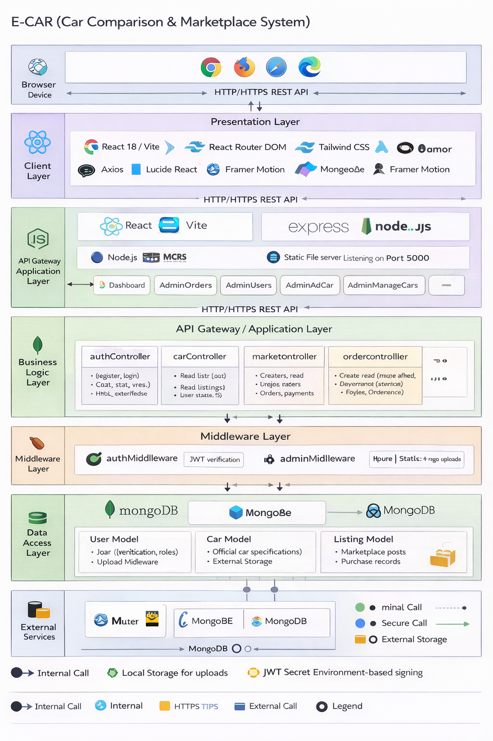

Technology Used
The E-CAR system is developed using the MERN stack, which includes MongoDB, Express.js, React.js, and Node.js. Each technology plays a specific role in the development process.
MongoDB is used as the database to store all application data such as users, cars, listings, orders, and payments. It is a NoSQL database that provides flexibility in handling structured and unstructured data.
Express.js is used as the backend framework to build RESTful APIs. It handles routing, middleware, and server-side logic efficiently.
Node.js is used as the runtime environment for executing server-side code. It enables asynchronous processing and improves the performance of the application.
React.js is used to build the frontend user interface. It provides a component-based architecture and ensures a responsive and interactive user experience.
Tailwind CSS is used for styling the frontend. It helps in creating modern and responsive UI designs quickly.
JWT (JSON Web Token) is used for authentication and authorization. It ensures secure access to protected routes and supports role-based access control.
Axios is used for making HTTP requests from the frontend to the backend APIs.

CONCLUSION
The E-CAR (Car Comparison & Marketplace System) project successfully achieves its objective of providing a unified platform for car comparison and marketplace functionalities. The system enables users to compare different cars based on specifications such as price, mileage, and performance, helping them make informed decisions before purchasing.
In addition to comparison, the platform also supports buying and selling of cars through a marketplace module. Users can list their own vehicles for sale, view listings from other users, and place orders with an integrated payment system. The inclusion of both direct car purchases and user-based listings makes the system flexible and practical.
The project is developed using the MERN stack, which ensures a scalable and efficient architecture. The use of JWT authentication provides secure access control, while the RESTful API design ensures smooth communication between frontend and backend. The system is responsive, user-friendly, and capable of handling multiple functionalities within a single platform.
Overall, the E-CAR system demonstrates how modern web technologies can be used to build a complete full-stack application that integrates comparison, marketplace, and transaction features. The project meets all functional requirements and provides a solid foundation for future enhancements.

